DICAS E CONCEITOS IMPORTANTES DE JAVASCRIPT:

1. *HORT-CIRCUIT EVALUATION:*

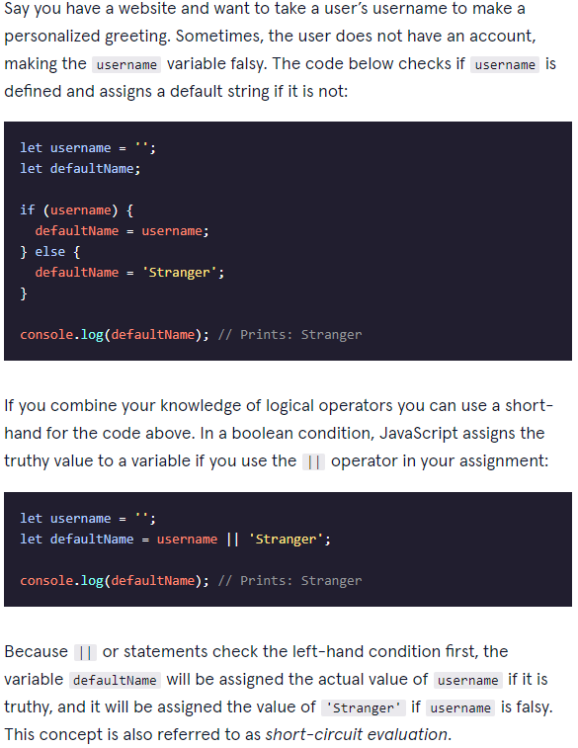

1. *TERNARY OPERATORS:*

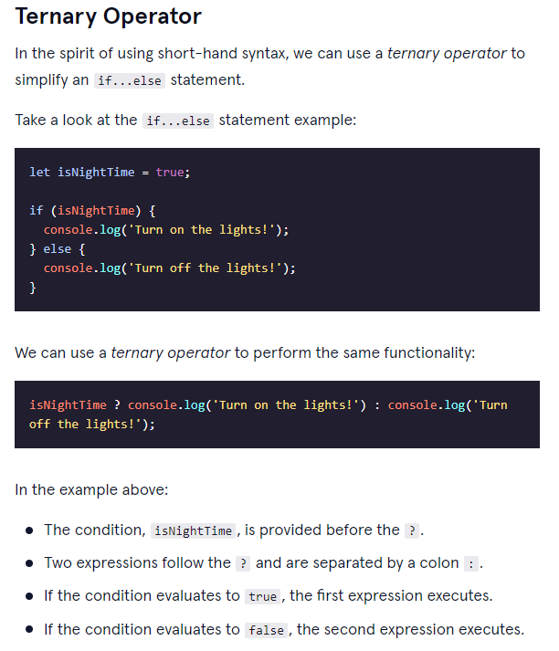

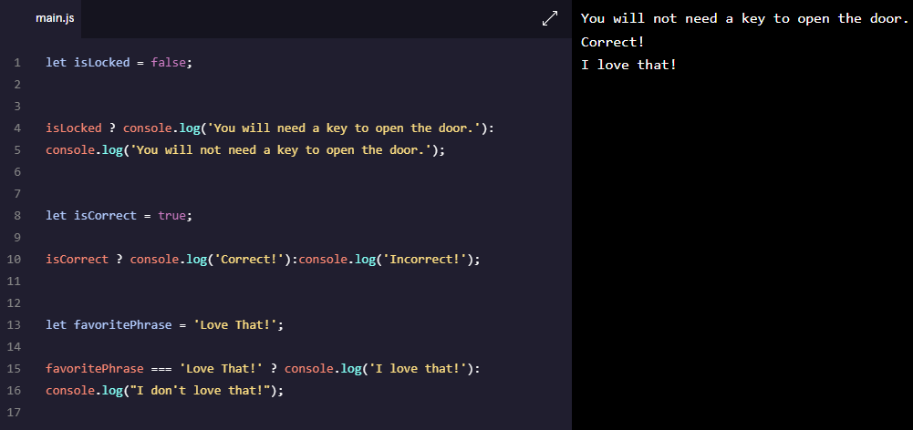

1. *SWITCH:*

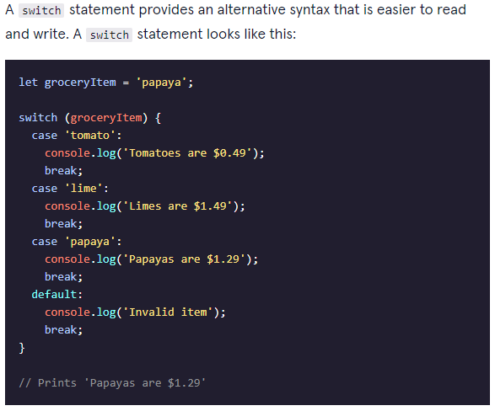

1. *MAGIC 8-BALL PJ:*

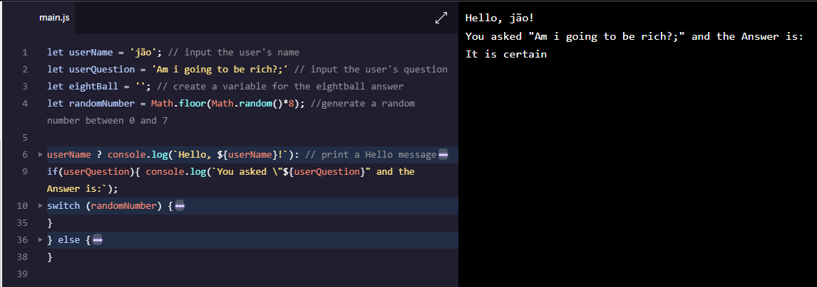

1. *RACE DAY PJ:*

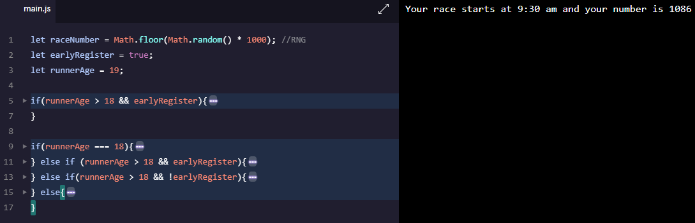

1. *SYNTAX REVIEW:*

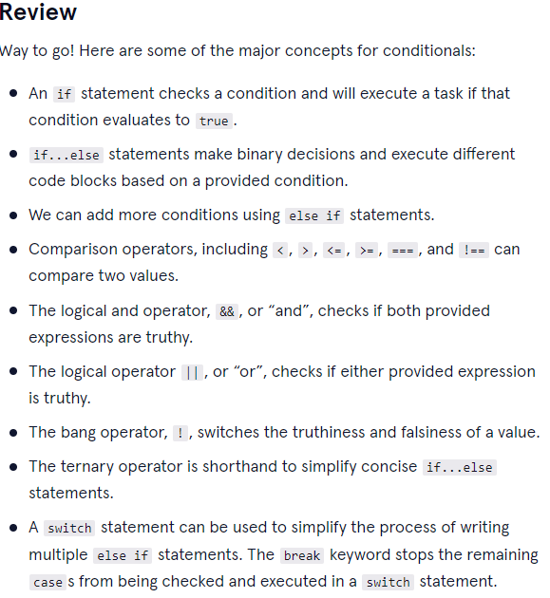

1. *ARRAY METHODS:*

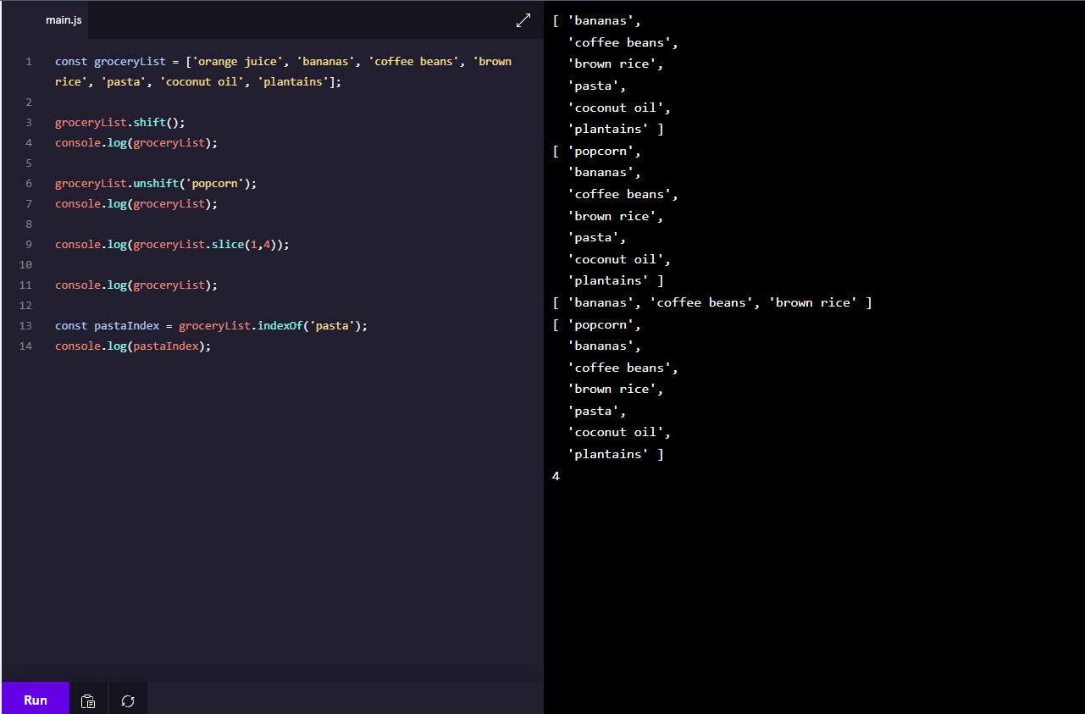

1. *NESTED ARRAYS:*

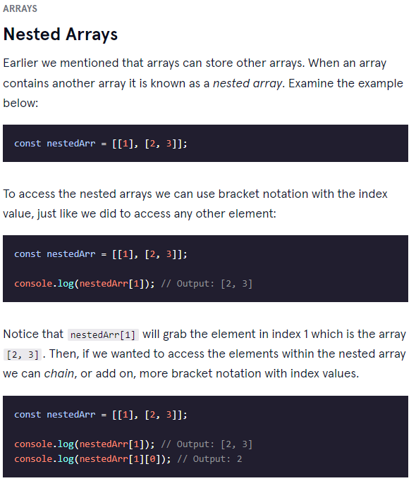

[***https://developer.mozilla.org/en-US/docs/Web/JavaScript/Reference/Global_Objects/Array***](https://developer.mozilla.org/en-US/docs/Web/JavaScript/Reference/Global_Objects/Array)

1. *FUNCTIONS:*

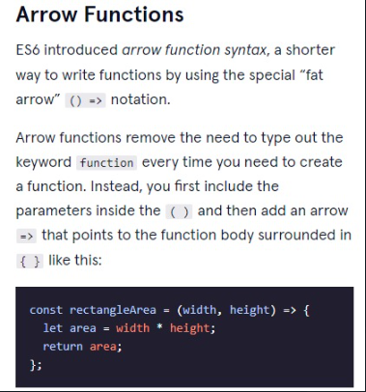

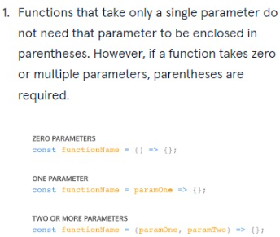

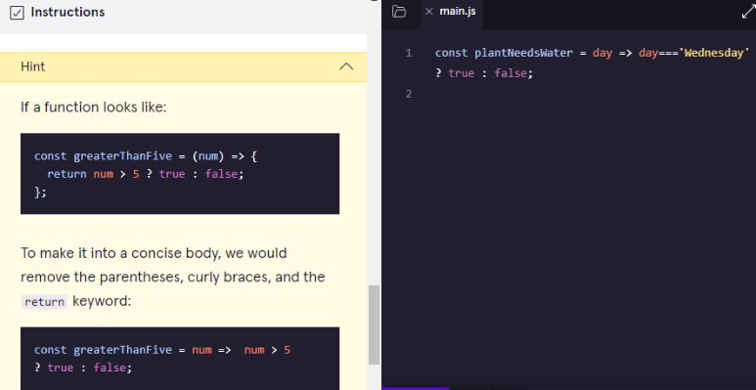

1. *.map() METHOD:*

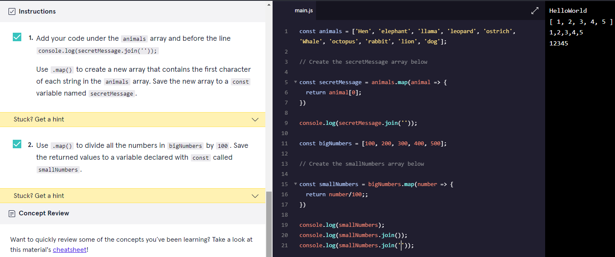

1. *.filter() METHOD:*

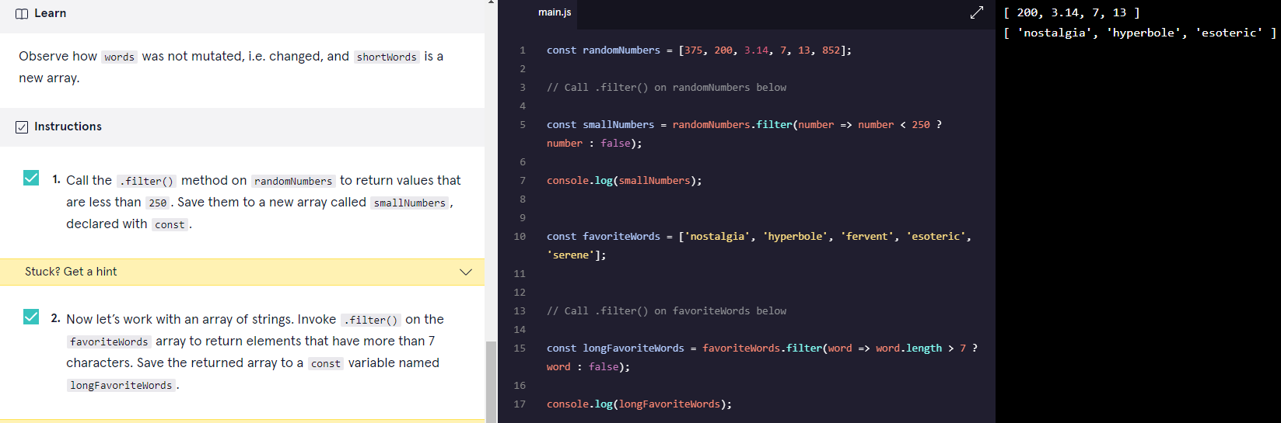

1. *.findIndex() METHOD:*

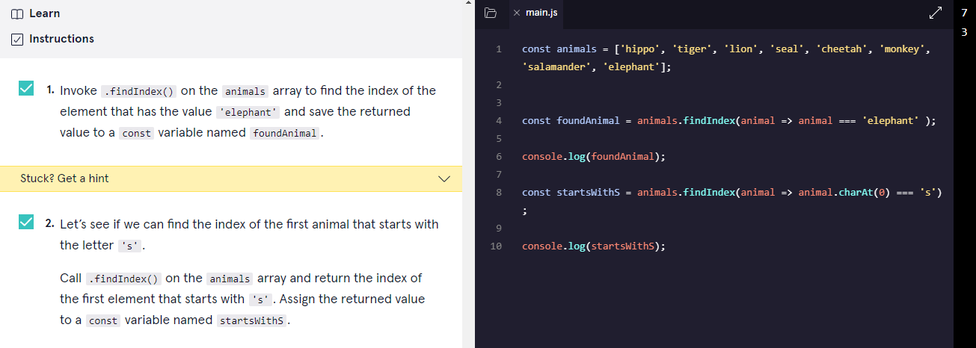

1. *.reduce() METHOD*

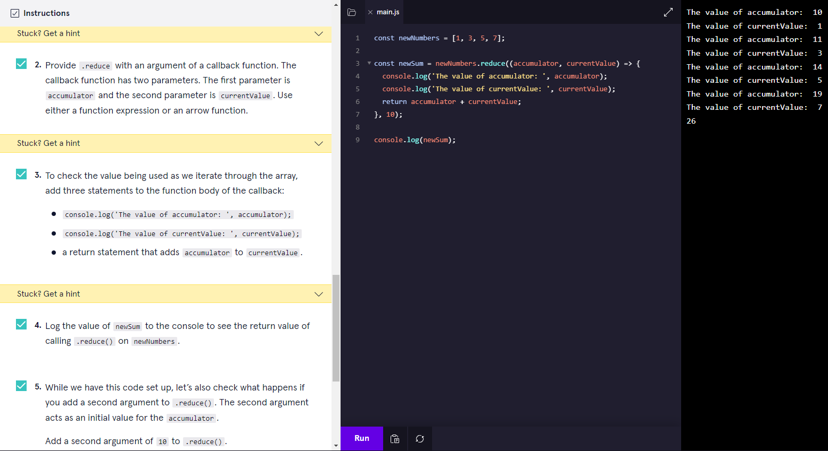

1. *ITERATIONS METHODS DOCUMENTATION:*

[*https://developer.mozilla.org/en-US/docs/Web/JavaScript/Reference/Global_Objects/Array#Iteration_methods*](https://developer.mozilla.org/en-US/docs/Web/JavaScript/Reference/Global_Objects/Array#Iteration_methods)

1. *OBJETCS – PASS BY REFERENCE*

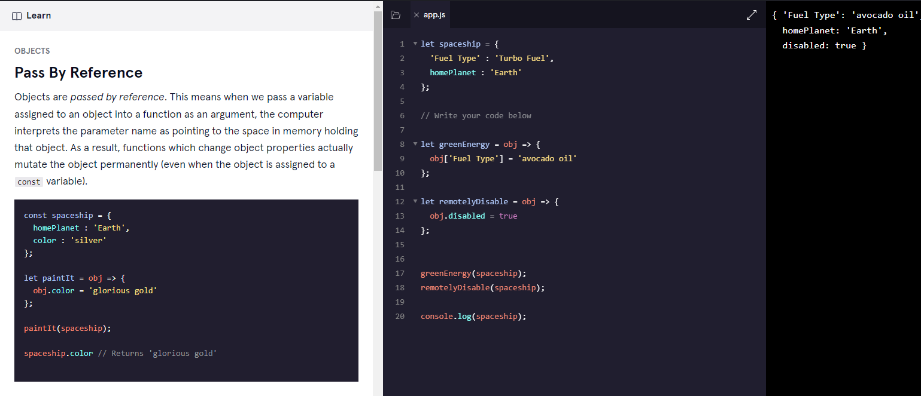

1. *LOOPING THROUGH OBJECTS: (FOR...IN)*

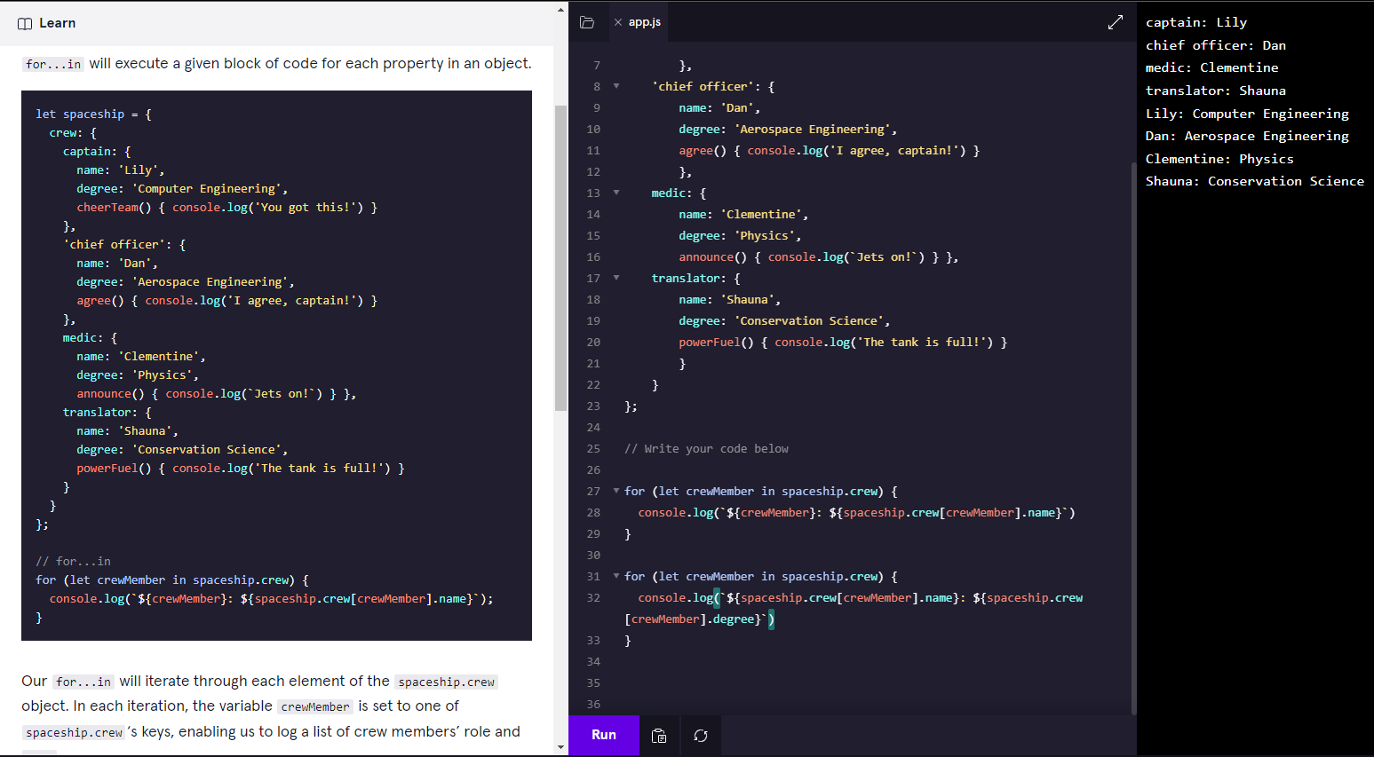

1. *“THIS” KEYWORD*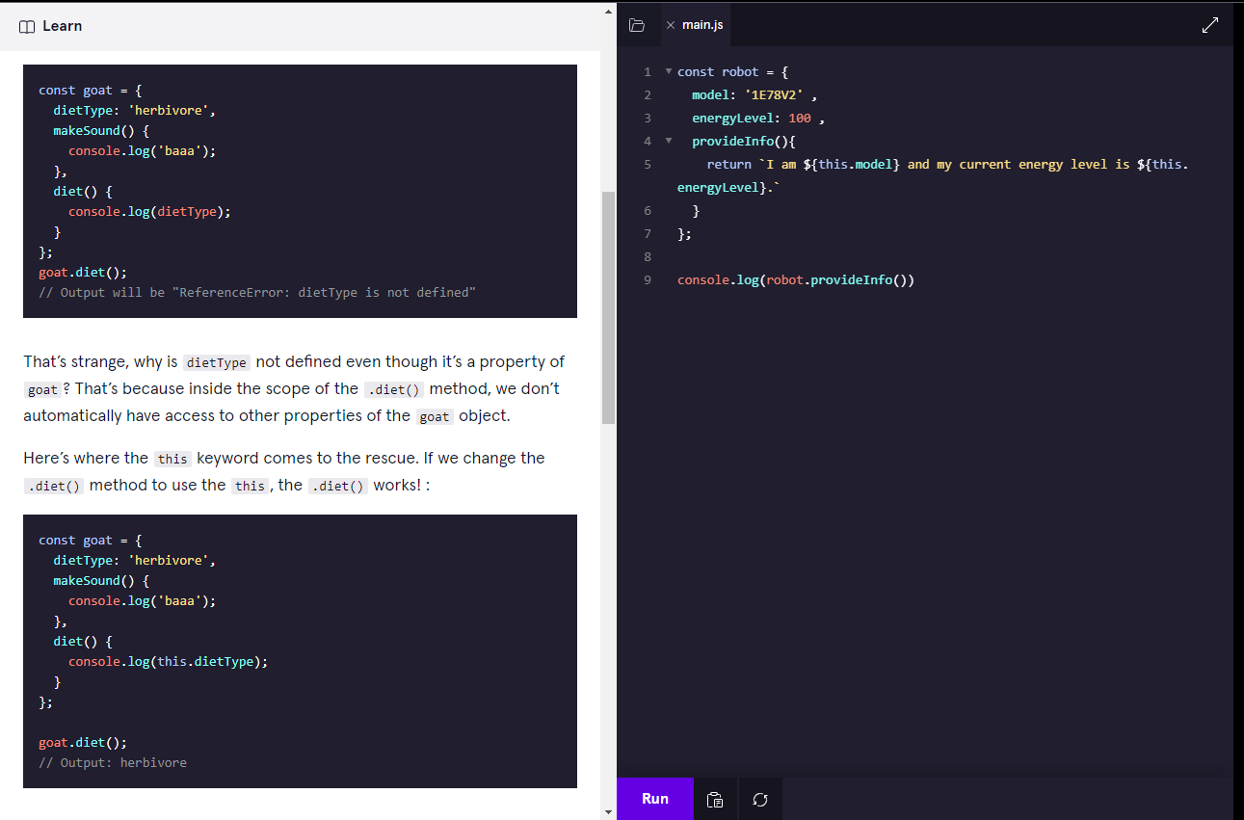

*P.S: DON’T USE ARROW FUNCTIONS WITH “THIS” KEYWORD!!*

1. *GETTER*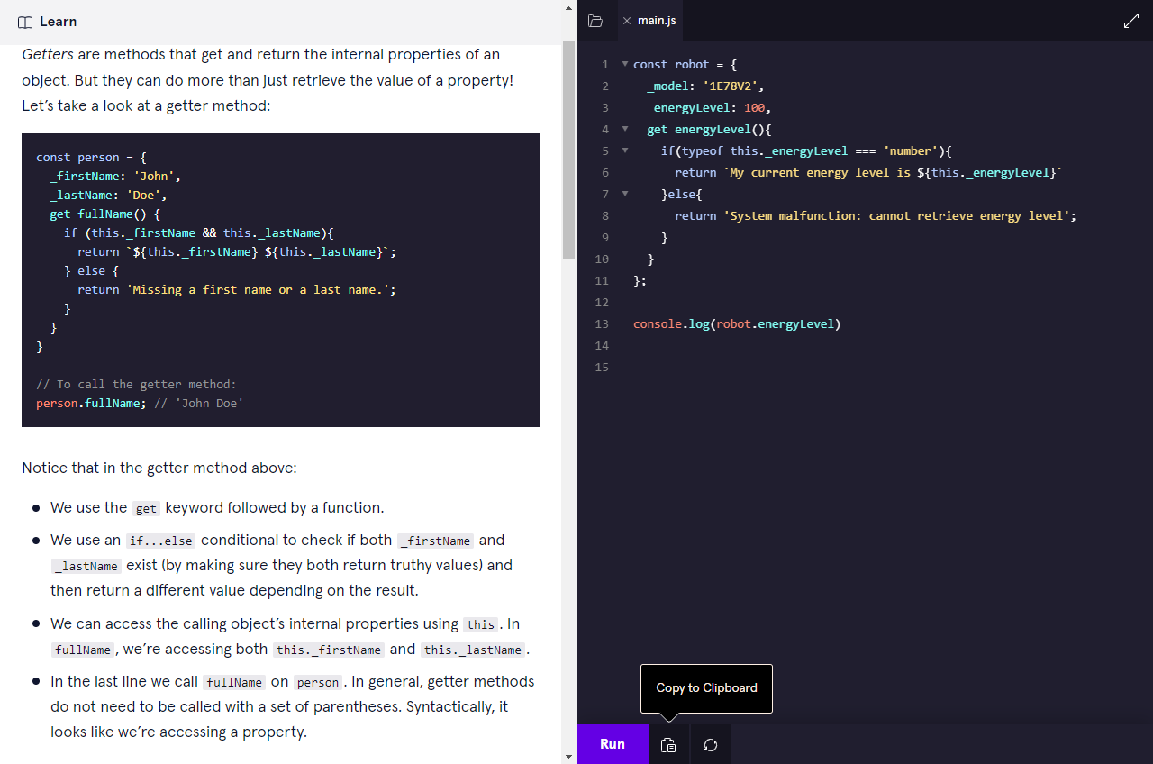
2. *SETTERS:*

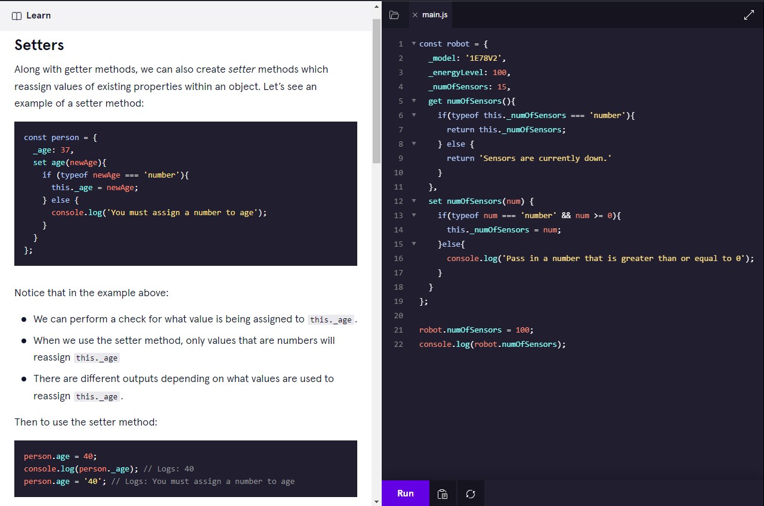

1. *FACTORY FUNCTIONS:* 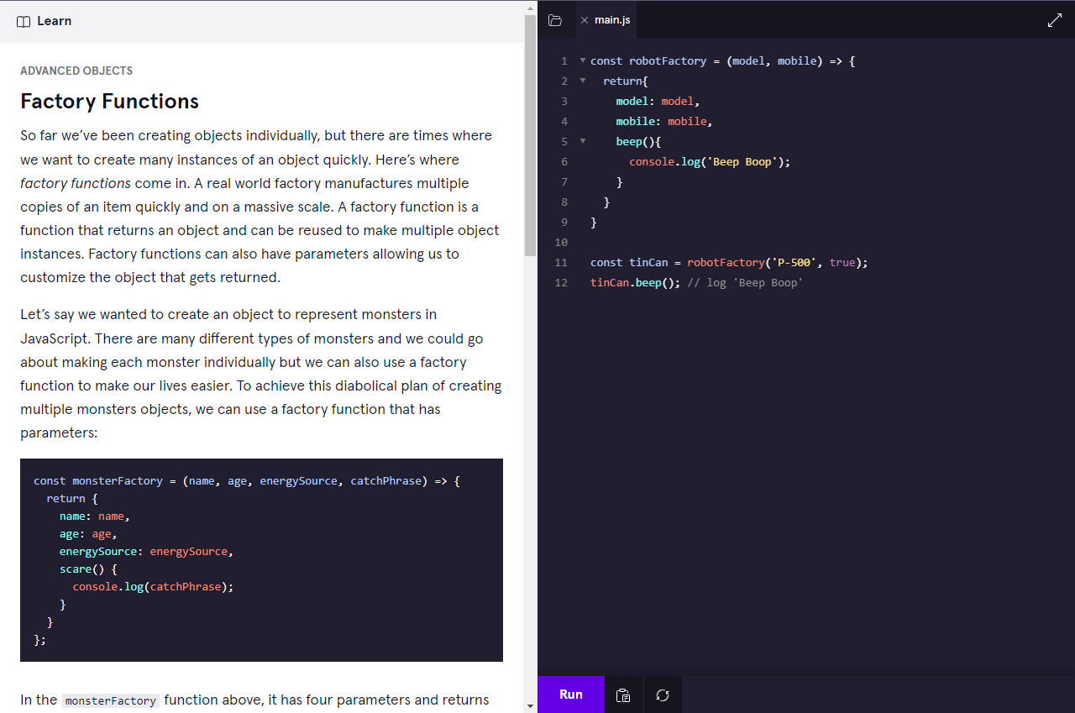
2. *PROPERTY VALUE SHOR-HAND*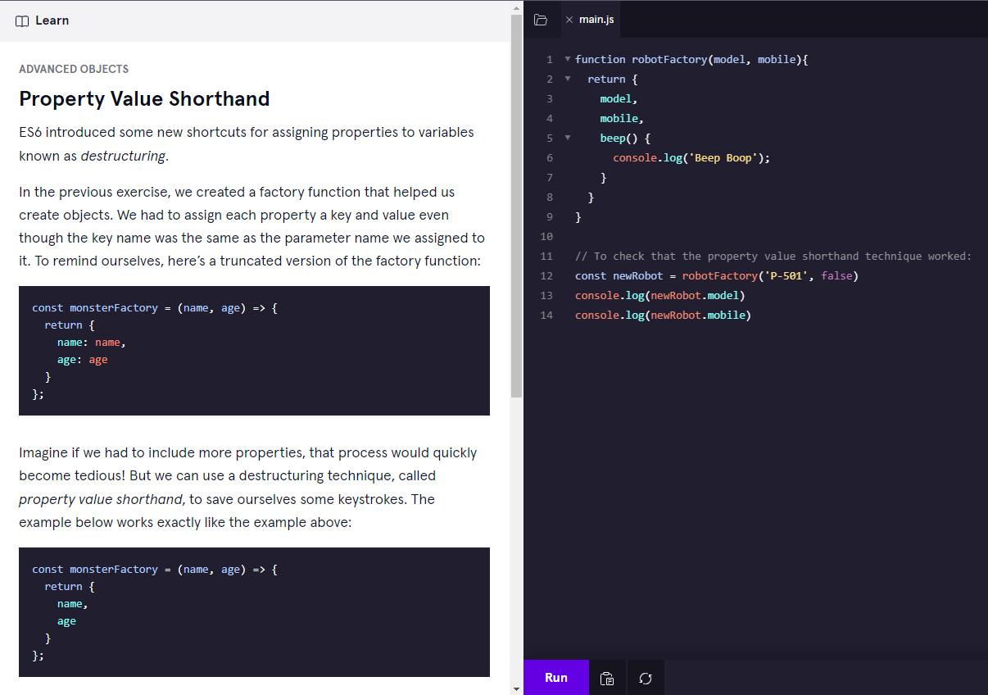
3. *DESTRUCTURED ASSIGNMENT*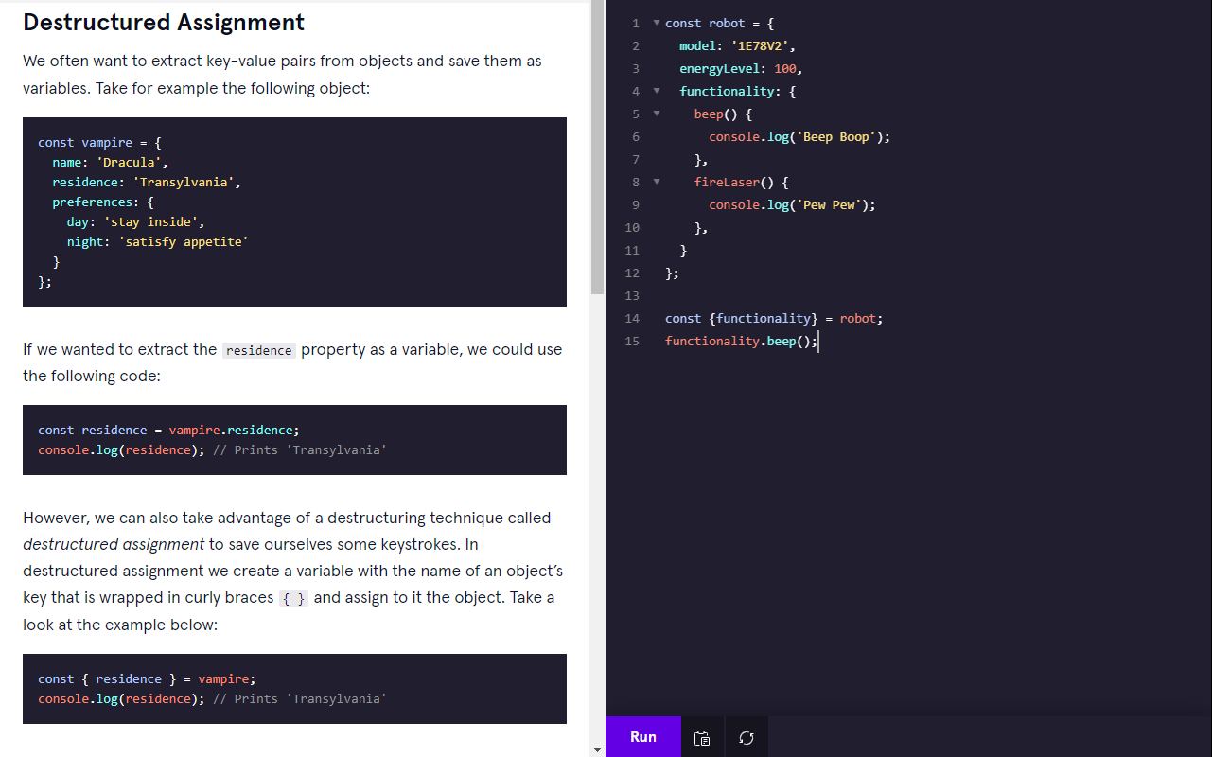

1. 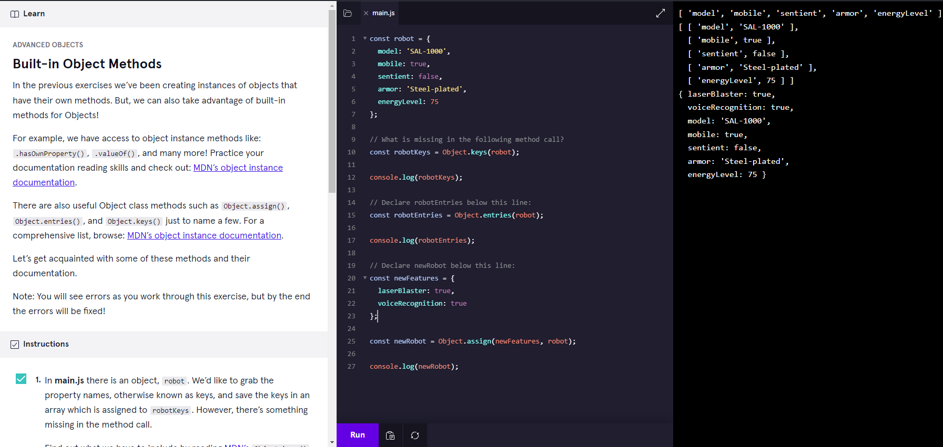*BUILT-IN OBJECT METHOD*

*https://developer.mozilla.org/en-US/docs/Web/JavaScript/Reference/Global_Objects/Object/assign*